Installing CheckMK on RHEL 9.x

Author: Jeremiah Holland

Date: 10/24/2025

Version: 1.0

To Install CheckMK raw edition and overcome initial challenges.

Revision History 3

Pre-Reqs 4

Required Documentation 5

Installation 6

Firewall 7

Download the software 7

Download CheckMK via wget 8

Verify the File Hash 9

Install the CheckMK package software 9

Verify Version 9

Create Site 9

Create a named site 10

Configure Site 10

Web GUI 11

Distributed Monitoring 12

Exit out of site configuration mode 13

Start the site 13

Log into Site 14

# Revision History

|  |  |  |
| --- | --- | --- |
| Date | Author | Update |
| 10/24/2025 | Jeremiah Holland | Initial Draft |
|  |  |  |
|  |  |  |
|  |  |  |
|  |  |  |
|  |  |  |
|  |  |  |

# Pre-Reqs

1. RHEL-9.x 64x ISO.

# Required Documentation

1. <https://checkmk.com/download?platform=cmk&distribution=redhat&release=el9&edition=cre&version=2.4.0p14>
2. <https://docs.checkmk.com/latest/en/install_packages_redhat.html>

# Installation

Run the following commands. Will most likely need sudo permissions.

## Firewall

root@linux# setsebool -P httpd_can_network_connect 1

root@linux# firewall-cmd --zone=public --add-service=http –permanent

root@linus# sudo firewall-cmd –permanet --add-port=6557/tcp

root@linux# firewall-cmd –reload

## Download the software

[2.4.0p14 Download Link](https://checkmk.com/download?platform=cmk&distribution=redhat&release=el9&edition=cre&version=2.4.0p14)

Ensure the following

* Distribution is set to Red Hat
* Release is set to 9.x
* CheckMK edition is set to Raw. Do not select Free/Trial
* Version – Most current

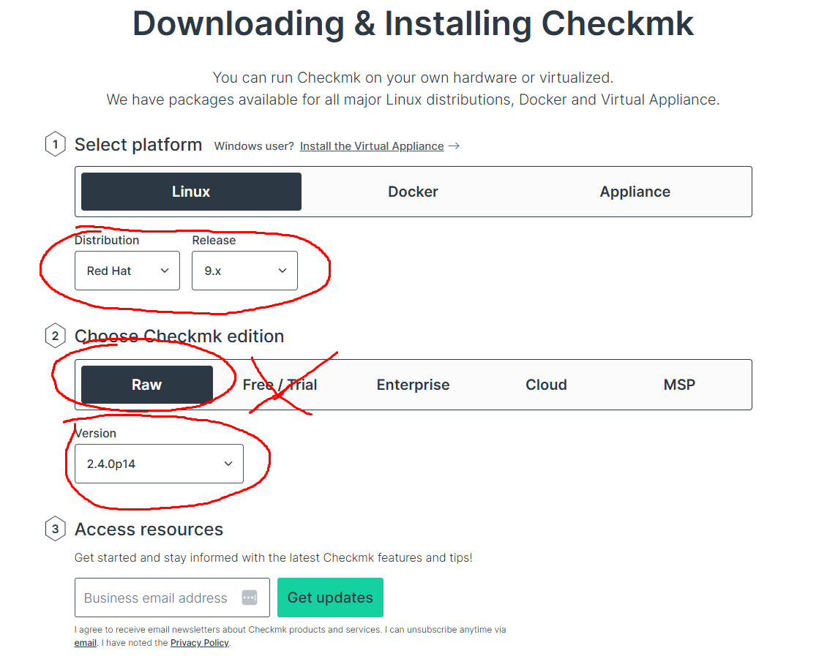

### Download CheckMK via wget

Root@linux# wget <https://download.checkmk.com/checkmk/2.4.0p14/check-mk-raw-2.4.0p14-el9-38.x86_64.rpm>

## Verify the File Hash

root@linux# wget <https://download.checkmk.com/checkmk/Check_MK-pubkey.gpg>

root@linux# rpm --import Check_MK-pubkey.gpg

root@linux# rpm -K check-mk-raw-2.4.0p13-el8-38.x86_64.rpm

## Install the CheckMK package software

root@linux# sudo yum install check-mk-raw-2.4.0p14-el9-38.x86_64.rpm

...

Software should successfully install.

## Verify Version

root@linux# omd version



# Create Site

## Create a named site

**DURING THE CREATION PROCESS A USERNAME AND PASSWORD TO LOG INTO THE GUI IS GENERATED. STORE THIS USERNAME AND PASSWORD SOMEWHERE SAFE.**

root@linux# sudo omd create <site_name>

(in my example the <site_name> will be monitoring and commands moving forward will reference the name of my site)

**DURING THE CREATION PROCESS A USERNAME AND PASSWORD TO LOG INTO THE GUI IS GENERATED. STORE THIS USERNAME AND PASSWORD SOMEWHERE SAFE.**

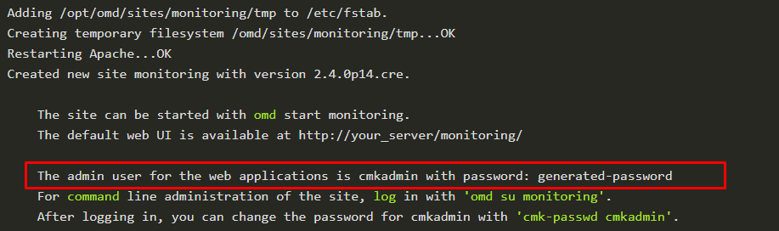

## Configure Site

Get into the Interactive settings widget.

root@linux# sudo omd su monitoring

OMD[monitoring]:~$ omd config

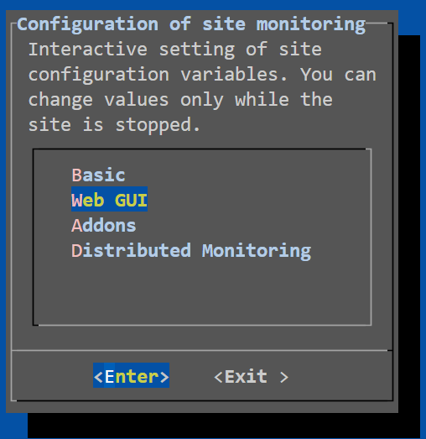

### Web GUI

Go to the Web GUI section and confirm the port that is being used. This will be the port that you use to connect to the website.

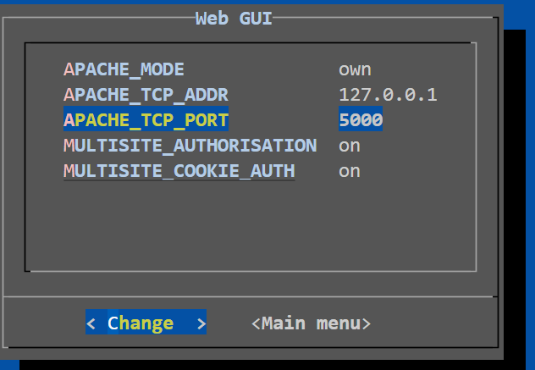

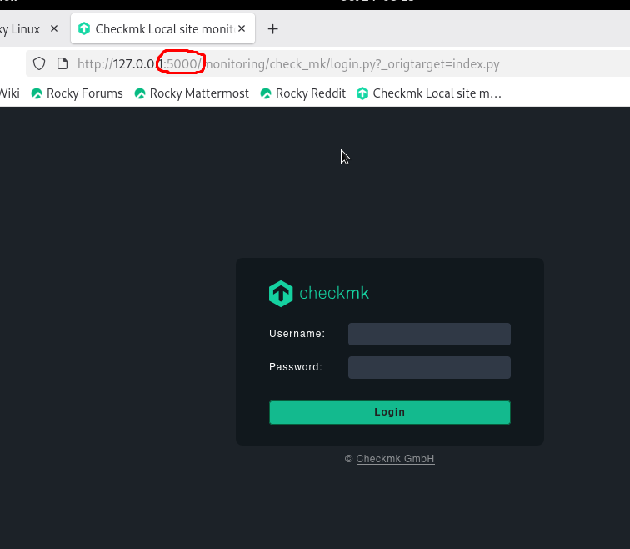

### Distributed Monitoring

Ensure the following settings:

* LIVESTATUS_TCP ON
* LIVESTATUS_TCP_ONLY_FROM 0.0.0.0 ::/0
* LIVESTATUS_TCP_PORT 6557
* LIVESTATUS_TCP_TLS OFF
* PIGGYBACK_HUB OFF

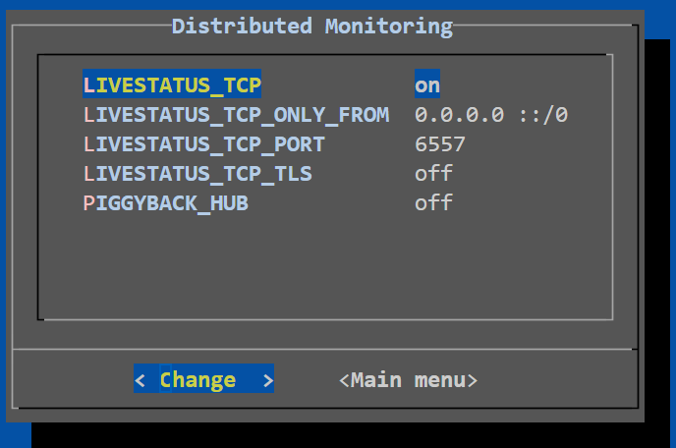Ensure LIVESTATUS_TCP_TSL is off

Exit out of the Configuration of Site Monitoring widget by selecting Main Menu -> Exit.

### Exit out of site configuration mode

OMD[monitoring]:~$ exit

# Start the site

root@linux# sudo omd start monitoring

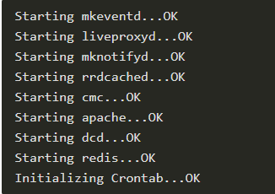

# Log into Site

The site is now up and running and should be accessible via the url:

<http://127.0.0.1:5000/monitoring>

Use the login credentials provided in the [Create a Named Site](https://1drv.ms/w/c/74c8a9b26450196d/EeToQApMwXpBstE6iYtjfLsBP6_QRB9mC4utzOQvmBQH4Q?e=FZYOts&nav=eyJoIjoiMTY3NDkwMDgyNSJ9) step.

